UNITED STATES
SECURITIES AND EXCHANGE COMMISSION

Washington, D.C. 20549

SCHEDULE 14A

Proxy Statement Pursuant to Section 14(a) of the
Securities Exchange Act of 1934

Filed by the Registrant ☒

Filed by a party other than the Registrant ☐

Check the appropriate box:

- Preliminary Proxy Statement

- Confidential, for Use of the Commission Only (as permitted by Rule 14a-6(e)(2))

- Definitive Proxy Statement

- Definitive Additional Materials

- Soliciting Material Under Rule 240.14a-12

ENOVIS CORPORATION
(Name of Registrant as Specified In Its Charter)

(Name of Person(s) Filing Proxy Statement, if other than the Registrant)

Payment of Filing Fee (Check the appropriate box):

- No fee required.

- Fee paid previously with preliminary materials.

- Fee computed on table in exhibit required by Item 25(b) per Exchange Act Rules 14a-6(i)(1) and 0-11.

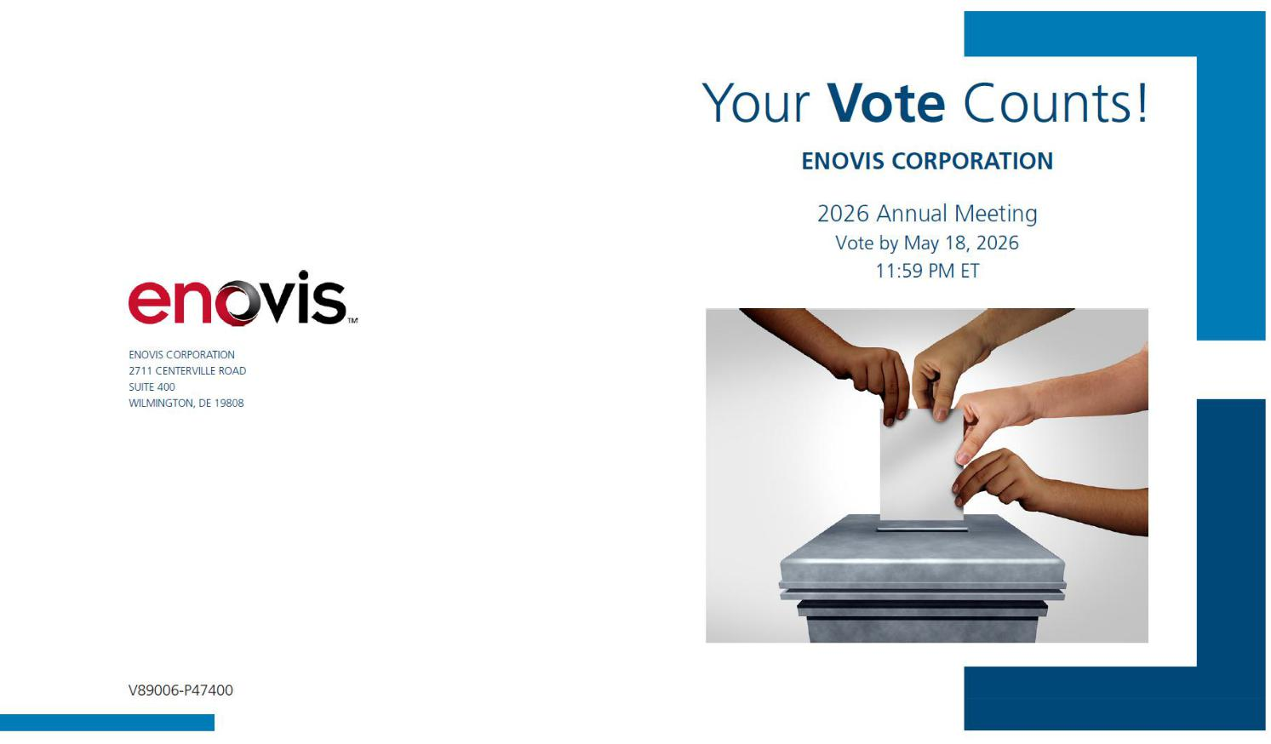

You invested in ENOVIS CORPORATION and it’s time to vote!

You have the right to vote on proposals being presented at the Annual Meeting. This is an important notice regarding the availability of proxy materials for the stockholder meeting to be held on May 19, 2026.

Get informed before you vote

View the Notice of 2026 Annual Meeting and Proxy Statement and Annual Report on Form 10-K online OR you can receive a free paper or email copy of the material(s) by requesting prior to May 5, 2026. If you would like to request a paper or email copy of the material(s) for this and/or future stockholder meetings, you may (1) visit www.ProxyVote.com, (2) call 1-800-579-1639 or (3) send an email to sendmaterial@proxyvote.com. If sending an email, please include your control number (indicated below) in the subject line. Unless requested, you will not otherwise receive a paper or email copy.
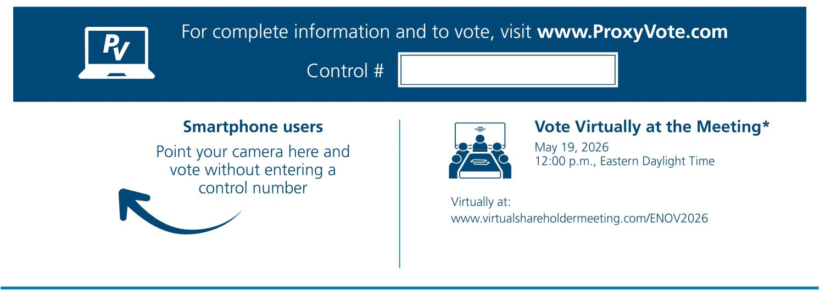

*Please check the meeting materials for any special requirements for meeting attendance.

Vote at www.ProxyVote.com

THIS IS NOT A VOTABLE BALLOT

This is an overview of the more complete proxy materials that

are available to you on the Internet. You may view the proxy
materials at www.ProxyVote.com or request a paper copy.
We encourage you to access and review all of the important

information contained in the proxy materials before voting.

Voting Items

Board

Recommends
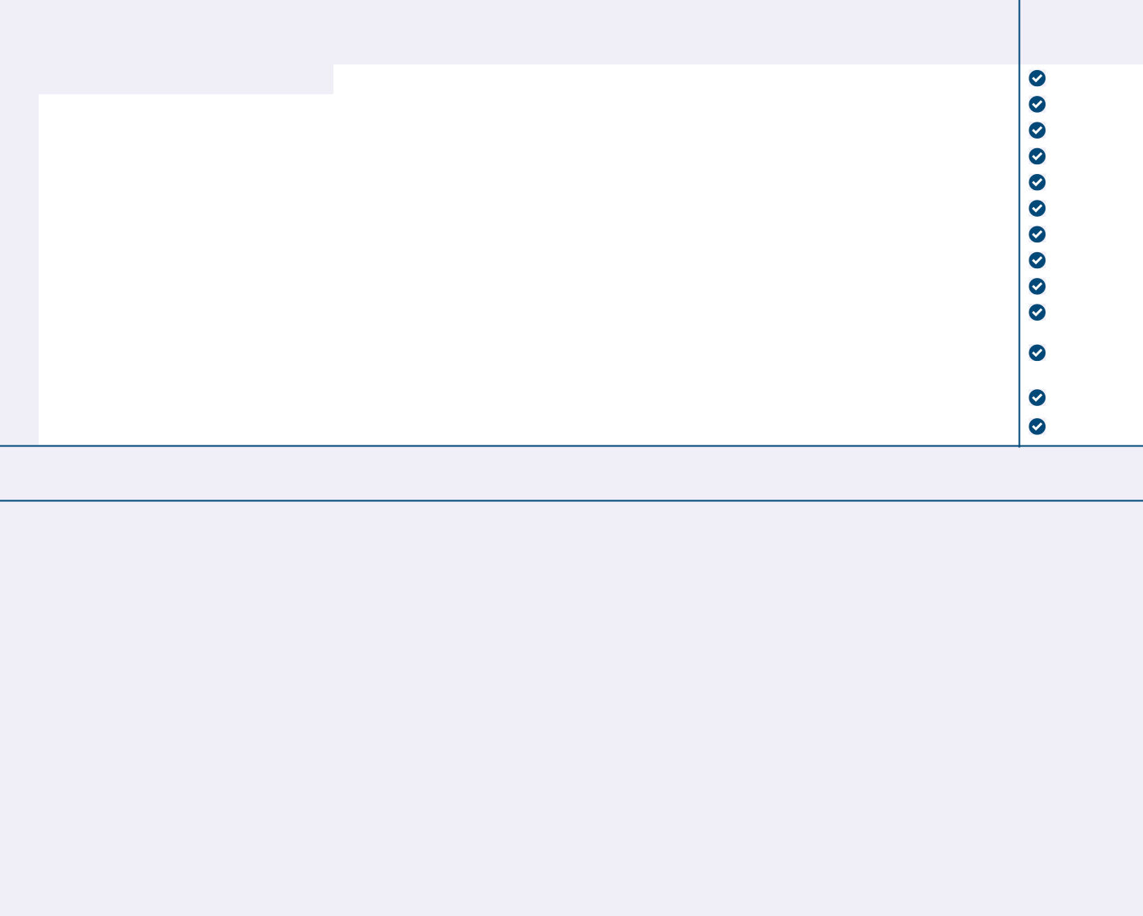

- 1. Election of Directors

Nominees:

1a. |  |  |  |  | For
 |  | Barbara W. Bodem |  |  | For
 | 1b. | Liam J. Kelly |  |  | For
 | 1c. | Angela S. Lalor |  |  | For
 | 1d. | Damien McDonald |  |  | For
 | 1e. | Philip A. Okala |  |  | For
 | 1f. | Christine Ortiz |  |  | For
 | 1g. | A. Clayton Perfall |  |  | For
1h. |  | Brady Shirley |  |  | For
1i. |  | Rajiv Vinnakota |  |  | For
1j. |  | Sharon Wienbar |  |  | For
2. |  | To ratify the appointment of Ernst & Young LLP as our independent registered public accounting firm for the fiscal |  |  | For
 |  | year ending December 31, 2026. |  |  | For
3. |  | To approve on an advisory basis the compensation of our named executive officers. |  |  | For
 | 4. | To approve an amendment to the Enovis Corporation 2020 Omnibus Incentive Plan. |  |  | For

NOTE: I authorize the proxies to vote according to their discretion on such other business as may properly come before the meeting or any adjournment or postponement thereof.

Prefer to receive an email instead? While voting on www.ProxyVote.com, be sure to click “Delivery Settings”.

V89007-P47400

